Timbers HOA: Phase 2 (Blue Side)

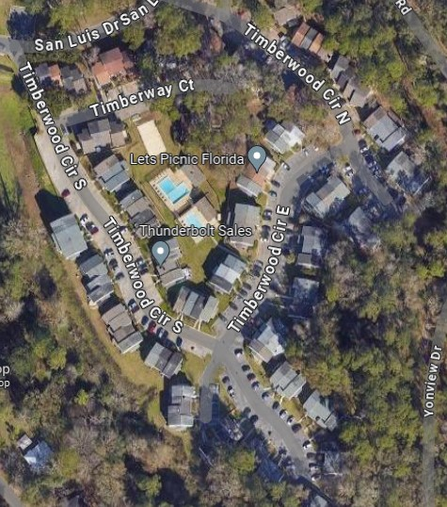
KEY
DUMPSTER
PET STATIONS

